ASSIGNNMENT -1.5

HT-NO:2303A51609

TASK-1
Task : Generate a Fibonacci series using github copilot
Prompt : Generate a fibanocci series in a language of python.

Code:
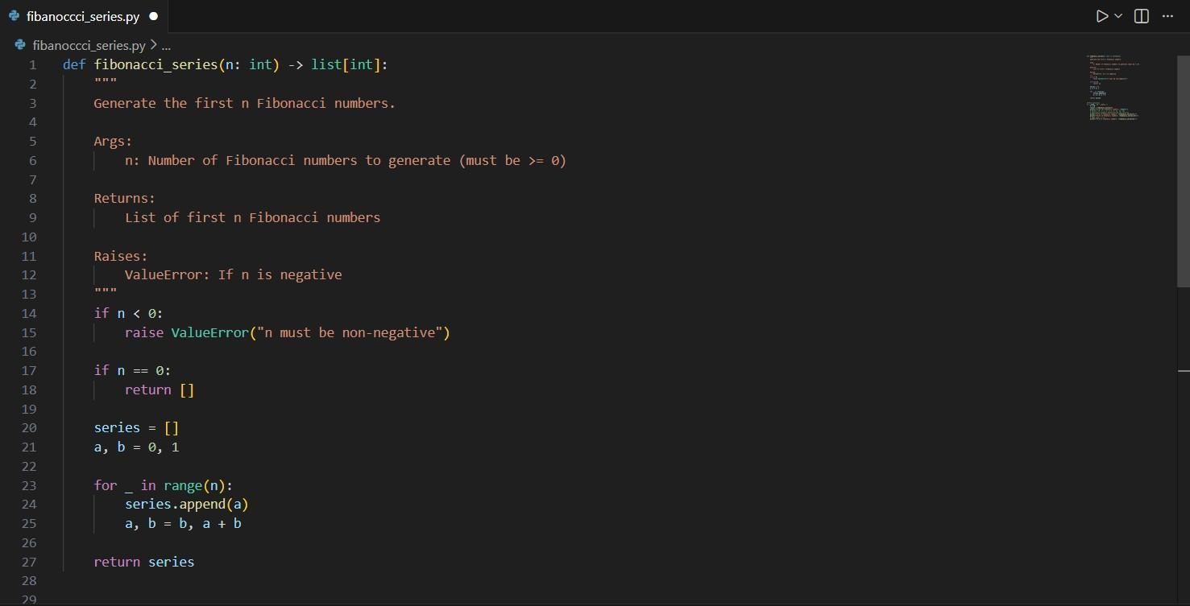

Output: 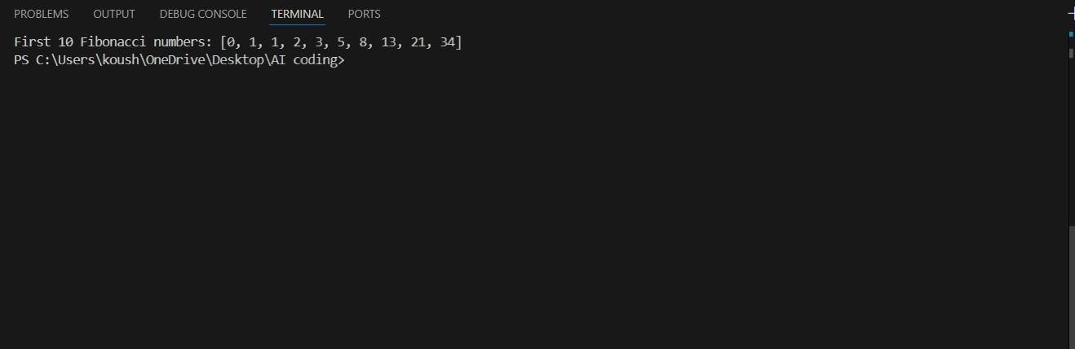
Observation:
- The function checks if the input n is negative and raises a ValueError if so, ensuring that only valid input is processed.
- If n is 0, the function returns an empty list, which is a valid output for the Fibonacci series.
- The Fibonacci series is generated using an iterative approach, which is efficient in terms of both time and space complexity.
- The function uses tuple unpacking to update the values of a and b, which are the two most recent Fibonacci numbers.
- The function returns a list containing the first n Fibonacci numbers, starting from 0.

TASK-2
AI-Generated Iterative vs Recursive Fibonacci Approaches (Different
Algorithmic Approaches to String Reversal)

Prompt:
Generate the code of AI-Generated Iterative vs Recursive
Fibonacci Approaches (Different
Algorithmic Approaches to String Reversal)
Code: 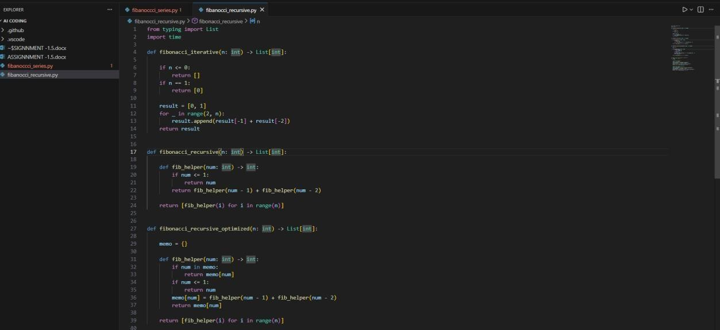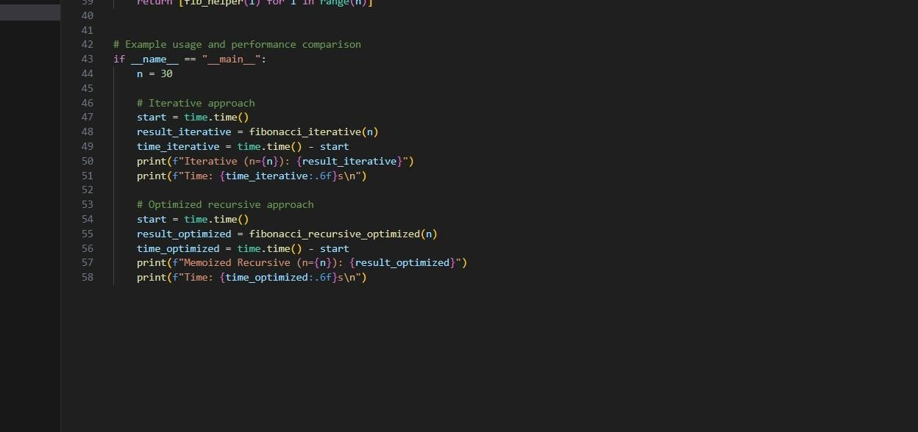
OUTPUT:
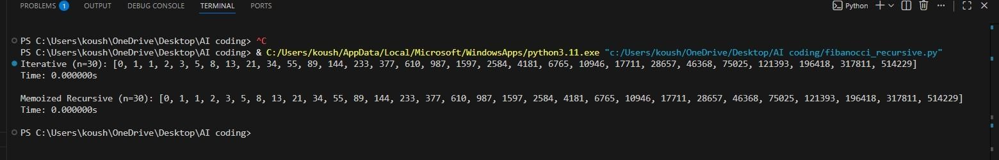

Observation: 1. The iterative approach is efficient and has a time complexity of O(n).
- The naive recursive approach has an exponential time complexity of O(2^n), making it inefficient for larger n.
- The optimized recursive approach with memoization significantly reduces the time complexity to O(n) by storing previously computed results.
- The module includes a performance comparison for the iterative and optimized recursive methods.
- The code is structured to allow easy testing and usage through the main block.

TASK-3

Prompt:
Generate the code of Comparative Analysis – Procedural vs
Modular Approach (With vs Without Functions) Code:
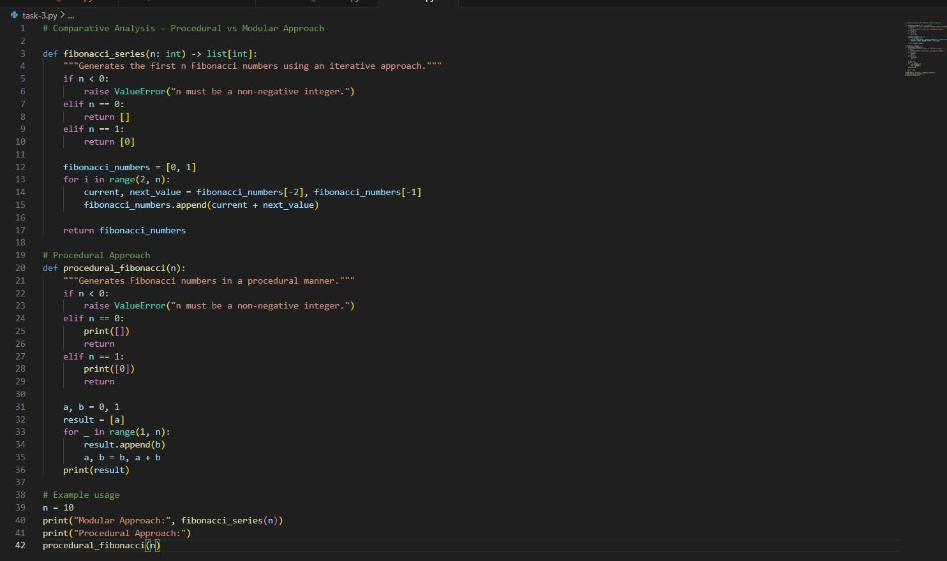

OUTPUT:
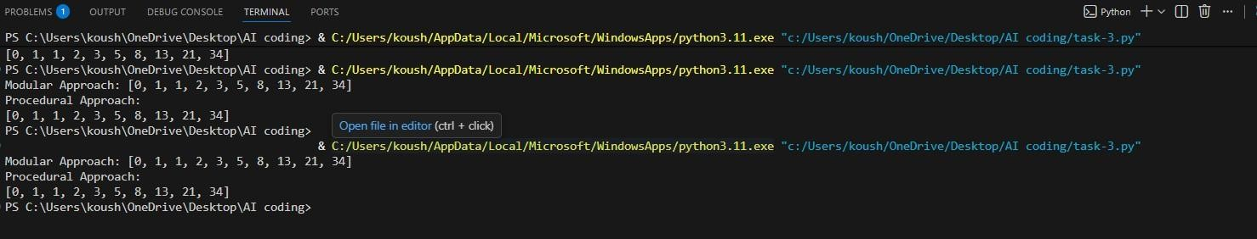

OBSERVATION:
- The modular approach is more versatile as it returns a list, allowing for further manipulation.
- The procedural approach is straightforward and may be easier for beginners to understand.
- Both approaches handle invalid input by raising a ValueError, ensuring robustness.
- The modular approach is more suitable for use in larger applications where function reuse is important.
- The procedural approach directly outputs results, which may be useful for quick checks or debugging.

TASK-4

Prompt:
Generate the code oModular Design Using AI Assistance (String Reversal Using Functions)

Code:
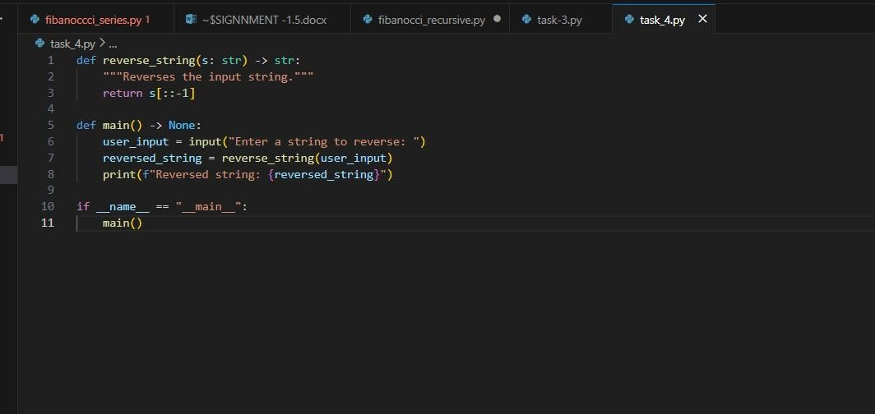

OUTPUT:
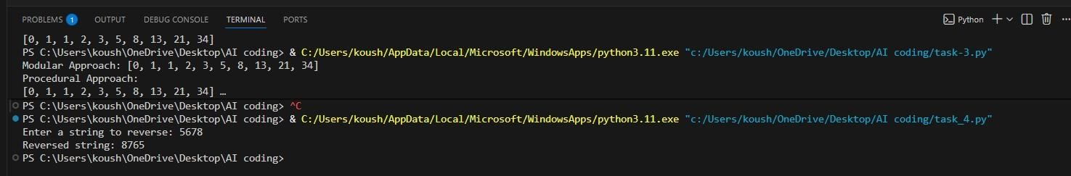

Observation:
- Simple and efficient: Uses built-in Python slicing for reversal
- Type hints provided: Function signatures include return type annotations
- User interaction: Implements interactive I/O with user prompts
- Proper entry point: Uses if __name__ == "__main__" guard clause
- Clean structure: Well-organized with separate concerns
(logic vs. I/O)
- No error handling: Does not validate empty strings or handle exceptions
- Edge cases: Will handle empty strings, special characters, and Unicode properly
- Documentation: Includes docstring for reverse_string() function

TASK-5
Prompt: generate the AI-Generated Logic Without
Modularization (String Reversal Without functions

Code :
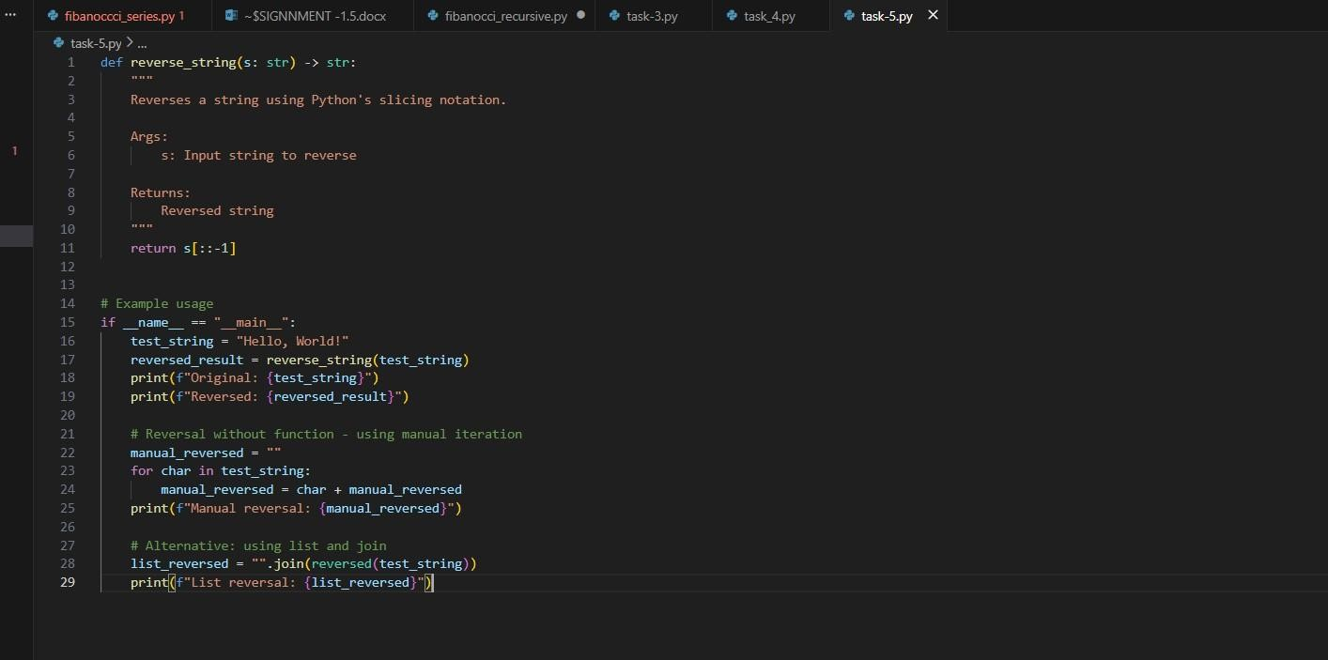
OutPut:
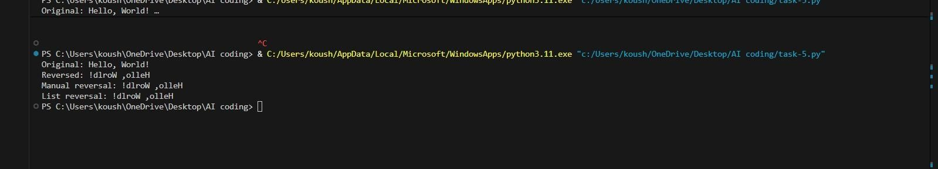
Observation:
- FUNCTION EFFICIENCY:
  - Uses Python's slice notation [::-1] which is O(n) time complexity
  - Efficient built-in method, implemented in C at the interpreter level
  - More performant than manual iteration approaches
- TYPE HINTS:
  - Properly typed with input parameter `s: str`
  - Clear return type annotation `-> str`
  - Improves code readability and enables IDE autocompletion
- DOCSTRING QUALITY:
  - Well-structured docstring following Google/NumPy style
  - Includes Args and Returns sections - Concise description of functionality
- EXAMPLE USAGE:
  - Demonstrates practical usage with a test string
  - Uses f-strings for modern, readable output formatting
  - Shows both original and reversed strings for comparison
- INCOMPLETE IMPLEMENTATION:
  - Code appears to be cut off with incomplete `manual_reversed = ""`
  - Suggests the task may include implementing alternative reversal methods
  - Likely intended to compare performance or implementation approaches
- BEST PRACTICES:
  - Uses `if __name__ == "__main__":` guard for main execution block
  - Separates function definition from test code
  - Clear variable naming conventions
- POTENTIAL ENHANCEMENTS:
  - Could add edge case handling (None, empty strings)
  - Could include performance benchmarks
  - Could implement alternative reversal methods for comparison

